TurnpointPurger Automation Suite – Technical Documentation

Title Page
- Project: TurnpointPurger Automation Suite
- Version: 1.0.0
- Scope: Python + Selenium stack that automates TurnPoint (tp1.com.au) data extraction, budgeting exports, and archival.

Executive Summary
TurnpointPurger is a Python automation toolkit that logs into the TurnPoint portal, scrapes all major client artifacts (details, schedules, notes, support/emergency plans, documents, NDIS budgets), downloads attachments, and normalizes the output into CSV/Excel-based archives under sequential “NexisID” folders. A Tkinter GUI wraps the automation with live logs, credential management, and purge history, while a CLI version can run headless. State is persisted locally in JSON so each client receives a unique universal prefix and duplicate purges can be detected.

Architecture Overview
- importcsv.py – Core automation pipeline. Manages state, Selenium driver creation, navigation, scraping, downloads, CSV writing, and final archival.
- turnpoint_purger_ui.py – Tkinter desktop UI that drives the pipeline, displays status, collects credentials, and exposes reset/history functions.
- NDISBUDGETER.py – Pandas-based helper that parses TurnPoint Excel budgets into entry CSVs.
- purger_state.py – Thread-safe JSON persistence of purge counters, client history, and duplicate metadata.
- build.py + PyInstaller specs – Packaging helpers for macOS/Windows (GUI + CLI).
- Assets & docs – Branding, README, packaging notes.
The architecture is modular/procedural (not classic Page Object Model). Helper functions are grouped by responsibility (state, scraping, downloads) and orchestrated by run_turnpoint_purge.

Functional Breakdown

importcsv.py
Component | Description
Global config | Loads .env (TP credentials, contact e-mail, optional archive root). Defines defaults and shared globals (CLIENT_ID, FILE_PREFIX, directories).
Logging | set_log_sink, log_message route log lines either to stdout or a GUI queue.
Operator state | prompt_operator_name, set_operator_name annotate logs with the operator codename.
Duplicate handling | get_client_last_purge, create_duplicate_report, confirm_duplicate_cli check JSON history and warn before re-running same client.
Credentials | configure_credentials, ensure_credentials, RUNTIME_* allow GUI to override .env values.
Archive management | assign_universal_sequence, ensure_archive_root, configure_client_context, update_final_client_name, finalize_output_directory, cleanup_old_csvs, reset_purge_data, calculate_directory_bytes handle folder structure, sequential numbering, cross-device rename fallback (copytree on Windows/Linux).
Selenium login | login(driver) navigates to BASE_URL, waits for the login form, sends credentials, and waits for /dashboard. Uses WebDriverWait with presence_of_element_located and url_contains.
DOM field scraping | extract_fields_on_page collects labels and adjacent inputs/values using composite XPaths. Handles selects (reads selected option), inputs, textareas, table siblings. Deduplicates label names via suffixing.
CSV writer | write_csv ensures consistent headers across all records per page.
Downloads | snapshot_downloads, wait_for_new_download, download_document_files (open each document link in new window via JS window.open, scroll to download button, click via execute_script, poll folder until new file arrives, rename to sanitized name, move into Documents subfolder). download_budget_excel uses the same pattern then calls process_budget_excel.
Page extractors | extract_client_details, extract_package_schedules, extract_notes, extract_info_sheet, extract_agreement, extract_contacts, extract_support_plan, extract_emergency_plan, extract_documents, extract_ndis_budget. Each constructs the relevant URL, loads it, waits for the dominant element (e.g., table, link text), scrapes records, and optionally triggers downloads. Notes extraction parses multi-line cells into date/time/author/note text.
WebDriver factory | build_chrome_driver(headless) composes Chrome options (disable prompts, set download dir, new headless, disable sandbox/dev-shm notifications).
Orchestration | run_turnpoint_purge(client_id, client_name=None, headless=False) orchestrates the end-to-end workflow:
- Reserves the next universal ID via reserve_universal_sequence, sets FILE_PREFIX.
- Configures directories and purges stale CSVs.
- Creates the Chrome driver and logs in.
- Iterates over pages_and_extractors, writing CSV outputs and renaming the final archive once a better client name is known.
- Downloads documents/budget Excel when relevant.
- On success, computes archive size, records event via record_purge_event, logs final summary, returns path.
- Always quits the driver and calls finalize_output_directory (which renames/copies working folder into final client name). |
| CLI entry | main() prompts for client ID and runs the purge. |
Selenium commands used:
- driver.get(url)
- find_element(By.NAME/XPATH/etc).send_keys/click
- driver.execute_script(...) for new tabs, scrolling, clicking, retrieving values.
- driver.switch_to.window
- WebDriverWait(...).until(EC.*) for login fields, page anchor elements, clickable download buttons.
- driver.current_window_handle, driver.window_handles.
- Polling download directory to ensure file completion (skip .crdownload).

turnpoint_purger_ui.py
- Subclasses tk.Tk; sets up styles, frames, neon progress bars, GIF animation.
- Uses queue.Queue to marshal logs from the core script (via set_log_sink).
- Widgets:
  - Visual panel with “Powered by Nexix365” badge, circular GIF (Pillow ImageSequence to crop to a circle).
  - Directive Console: credential display, “Set Purging Credentials” (opens modal, collects email/password, masks password in label), client ID entry, headless checkbox, Engage/Reset buttons.
  - Log panel: ScrolledText for live logs, ASCII signature, global watermark.
- Event handlers:
  - _handle_engage spawns a background thread to call run_turnpoint_purge with current client ID/headless flag.
  - _execute_purge wraps call, enqueues success/failure messages, displays message boxes, refreshes counters.
  - _handle_reset_purge confirms and calls reset_purge_data.
  - _handle_set_credentials opens a dialog (Tkinter Toplevel) to collect email/password, validates non-empty, calls configure_credentials, updates display, logs change.
  - _prompt_operator_name prompts user for codename and calls set_operator_name.
  - _refresh_sequence_stats reads get_purge_statistics to show “Next Sequence / Purged count”.
  - _refresh_credential_display masks password with asterisks.
  - _drain_log_queue periodically transfers log messages to the text widget.
  - _set_running starts/stops progress bars and toggles button text.
  - _load_profile_animation uses Pillow to crop assets/maindp.gif into a circular frames list, then _animate_profile_gif cycles via after.
- GUI uses messagebox.showinfo/showerror for results.

NDISBUDGETER.py
- Utility for parsing Excel budgets (leverages pandas).
- auto_detect_excel_file() looks for .xlsx/.xls in latest NexisID folders or root, biased toward the last processed ID from purger_state.
- process_budget_excel() reads workbook, writes a raw CSV backup (Main_Agreement.csv), splits each “Agreement entry” block by day rows into separate CSV files under Entries/. Returns summary dict.
- generate_budget_exports() is a CLI helper; auto-detects spreadsheets, prompts user, and calls process_budget_excel.

purger_state.py
- Thread-safe JSON persistence of purge state under ~/.turnpoint_purger/purger_state.json.
- Maintains next_universal_id, purged_count, per-client last purge metadata, and a history log (capped at 200).
- APIs: get_purge_statistics, reserve_universal_sequence, get_client_last_purge, get_recent_history, record_purge_event, reset_state.
- record_purge_event increments counters, stores bytes/timestamps/operators, and ensures next_universal_id always increases.

build.py / specs
- build.py installs PyInstaller if missing, then runs GUI/CLI specs with platform-specific dist paths (dist/macos, dist/windows).
- turnpoint_gui.spec bundles turnpoint_purger_ui.py, includes assets/, hidden imports for NDISBUDGETER/importcsv/Pillow modules, and creates both EXE and .app bundle.
- turnpoint_cli.spec bundles the CLI entry.
Other files: README, packaging notes, requirements.

JavaScript & DOM Interaction Mapping
- Window handling: driver.execute_script("window.open(arguments[0], '_blank');", href) to open document detail pages in new tabs without relying on link targets.
- Scrolling: driver.execute_script("arguments[0].scrollIntoView(true);", element) ensures buttons are visible before clicking.
- Button clicks: driver.execute_script("arguments[0].click();", download_btn) sidesteps overlay issues and triggers file downloads reliably.
- Selectors: heavy use of XPath to locate forms (//input[@type='submit']), tables, download panes, etc. The scripts interact with DOM nodes representing TurnPoint forms, download buttons, and table rows.
- No direct JS injection beyond execute_script used for UI actions, so no custom DOM manipulation beyond scroll/click/open.

Dependency & Integration Mapping
- Python Standard Lib: os, time, shutil, pathlib, csv, json, threading, queue, datetime.
- Third-party:
  - selenium (WebDriver, waits, By, EC).
  - python-dotenv for .env.
  - pandas, openpyxl for Excel parsing (NDIS budget).
  - tkinter for GUI.
  - Pillow (Image, ImageSequence, ImageTk) for GIF rendering.
  - PyInstaller (packaging).
- External system: TurnPoint web portal (https://tp1.com.au). No REST APIs; all interactions are via browser automation.
- Credential flow: .env → TP_USERNAME/TP_PASSWORD; GUI can override via configure_credentials.
- Chrome downloads: Selenium-managed Chrome uses download.default_directory to drop files into the working folder and the script renames them.
- Data persistence:
  - PurgedClients/ per user (or override).
  - JSON state file ~/.turnpoint_purger/purger_state.json.
  - _duplicate_reports/ CSV notices.
  - CSV outputs + Excel budgets per client.

Database/Storage Section
- No database. Storage details:
  - PurgedClients/<NexisID ClientID>/ working folder. Contains CSVs for each page, downloaded documents, and NDIS_Budget_Exports/.
  - Final folder renamed to include client name (<NexisID CLIENT NAME (ID)>); cross-device or permission issues fallback to copytree.
JSON state file with structure:
{
"next_universal_id": 100003,
"purged_count": 2,
"clients": {
"56851": {
"universal_id": 100001,
"client_name": "KHAIR Adam",
"bytes": 1234567,
"timestamp": "2024-11-12T13:45:01.234567+00:00",
"operator": "Farhan"
},
...
},
"history": [ ... up to 200 entries ... ]
}

  - _duplicate_reports/<ClientID>_duplicate_notice.csv warns when a client was purged before.

Diagrams

Automation Workflow Sequence Diagram (textual)
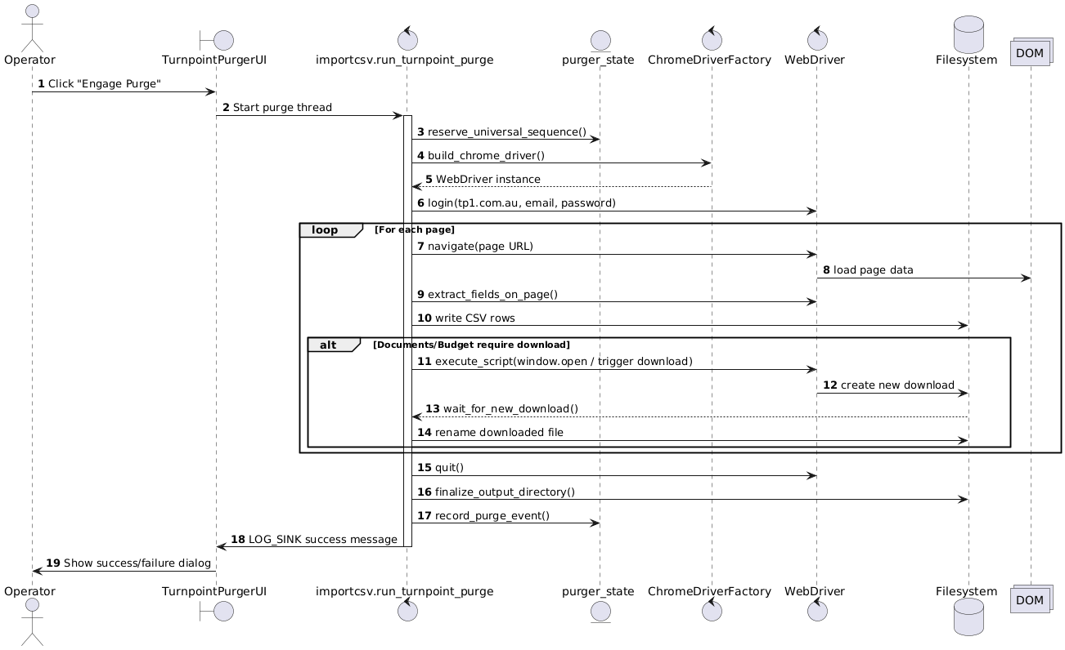

JS Interaction Analysis
- window.open – opens each document detail page in a new tab for downloading; needed when anchor targets open modals/popups.
- scrollIntoView(true) – ensures clickable buttons are visible; prevents Selenium from failing due to “element not interactable”.
- arguments[0].click() – bypasses overlay/pop-up issues where Selenium’s .click() might be blocked.
- Combined with WebDriverWait(... element_to_be_clickable) ensures the DOM is ready before executing JS.

Identified Issues / Code Smells
- Global mutable state: importcsv.py relies on many globals (CLIENT_ID, OUTPUT_DIR, LOG_SINK). Makes multithreading beyond the current single background thread risky.
- No explicit Page Objects: selectors are scattered in extract_*; changes to the site require editing multiple areas.
- Hard-coded waits: in wait_for_new_download or WebDriverWait with short timeouts may fail on slow networks; consider parameterizing.
- Exception swallowing: extract_* wrappers catch generic Exception and only log; critical errors (e.g., login failure) may go unnoticed.
- Cross-device rename fallback: handles Errno 18 but now also needs to handle Windows PermissionError (proposed fix). Keep verifying after packaging.
- Limited credential validation: GUI shows masked password but does not test login until run-time.
- GUI not resizable/maximized: on Windows users requested scaling; requires Tk state adjustments.

Recommendations
- Encapsulate selectors in Page Object classes or at least constants; simplifies maintenance.
- Centralize waits and timeouts for better tuning and diagnostics.
- Add structured logging (e.g., Python logging) to emit JSON logs for monitoring.
- Implement retry/backoff for download polling and HTTP navigation.
- Parameterize archive roots per platform (already using env var; encourage Windows packaging to set %PROGRAMDATA% or ask user).
- Add CLI options for headless mode, custom client IDs, or debug logging.
- Unit-test helper utilities (e.g., calculate_directory_bytes, purger_state) to avoid regression.

Closing
The provided codebase is a cohesive procedural automation suite that relies on Selenium WebDriver to drive TurnPoint, Tkinter for user interaction, and local file/JSON persistence for artifacts and state. With the documentation above—covering architecture, detailed function behavior, DOM/JS interactions, storage mappings, and diagrams—you can package this into a PDF or extend the system confidently.

